Meeting AGENDA

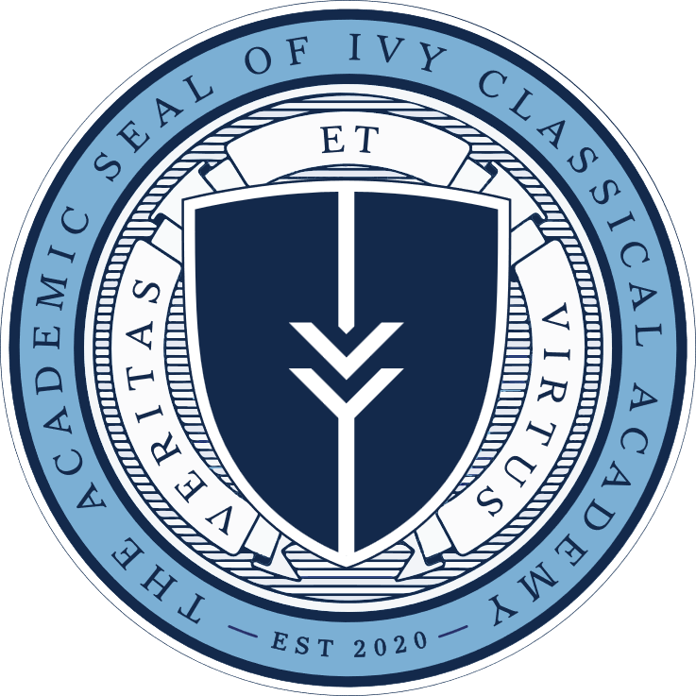

January 9, 2024
Board of Directors
Ivy Classical Academy

- Review and Approval of Minutes of Last Board of Director’s Meeting

- Vote on Soren Geiger’s Election to the Board of Directors

- Regional Services Agreement with American Classical Education Foundation

- Teacher’s Retirement Systems of Alabama Retirement Program

- Teacher’s Retirement Systems of Alabama Benefits Program

- Head of School’s Report

  - Hiring

  - Enrollment

- Elmore County Pre-Opening Checklist

- New Business

- Adjournment

